[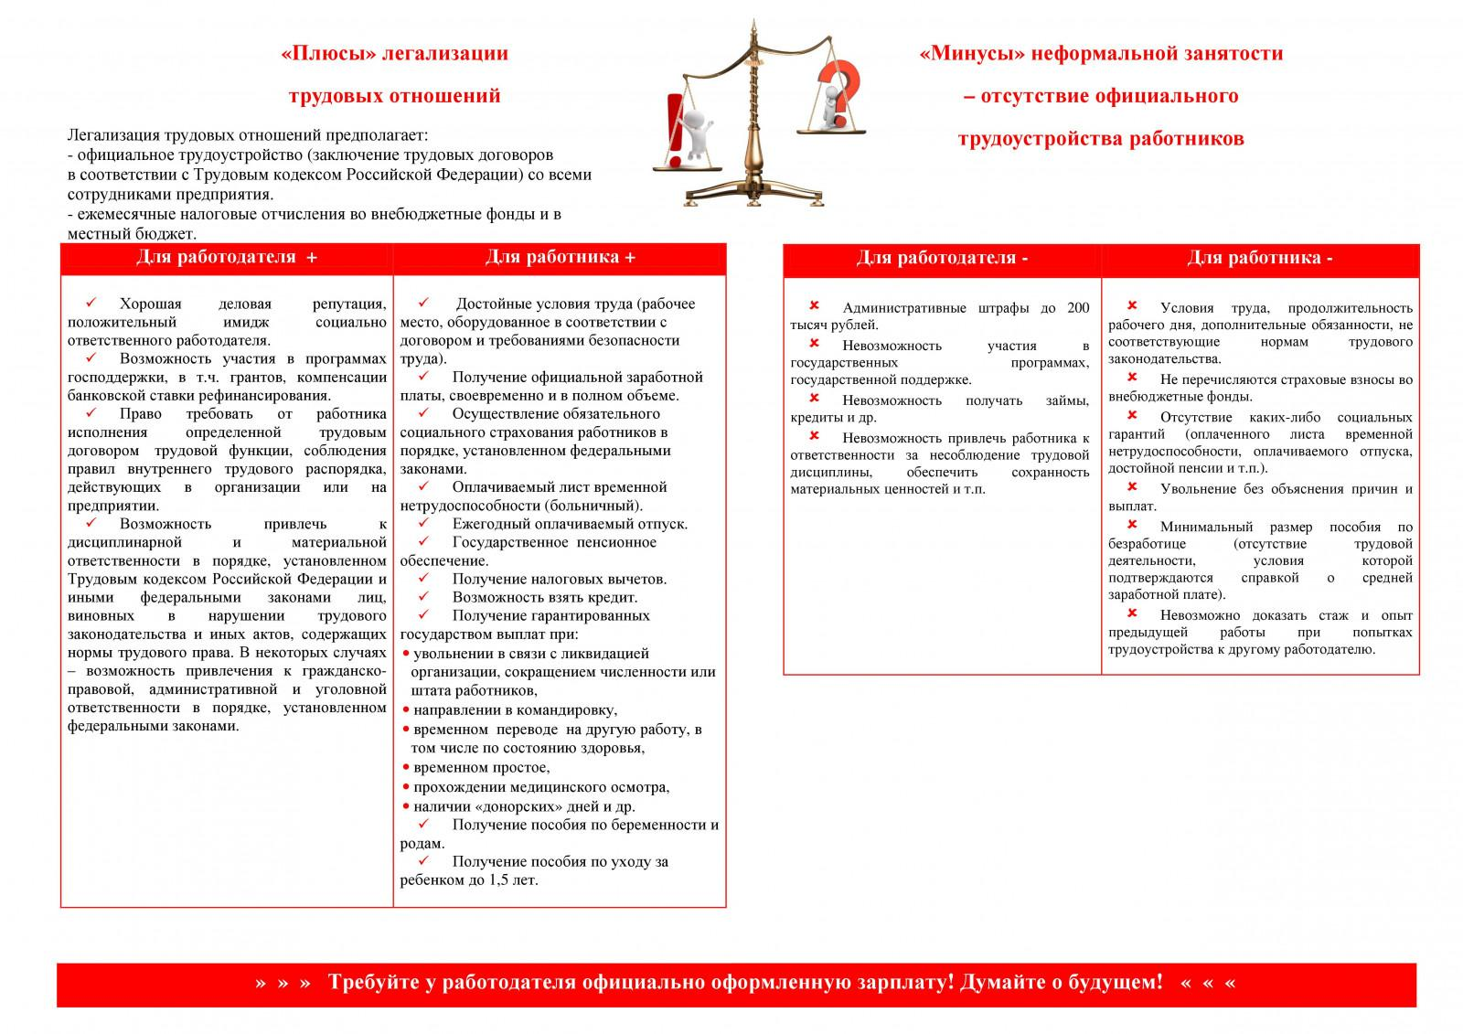](http://www.yashrn.ru/images/files/KompoEconom/Neformalnaya_zanyatost/2021/NZ00001.jpg)